**Usage of Sugarcane bagasse in construction and Industries**

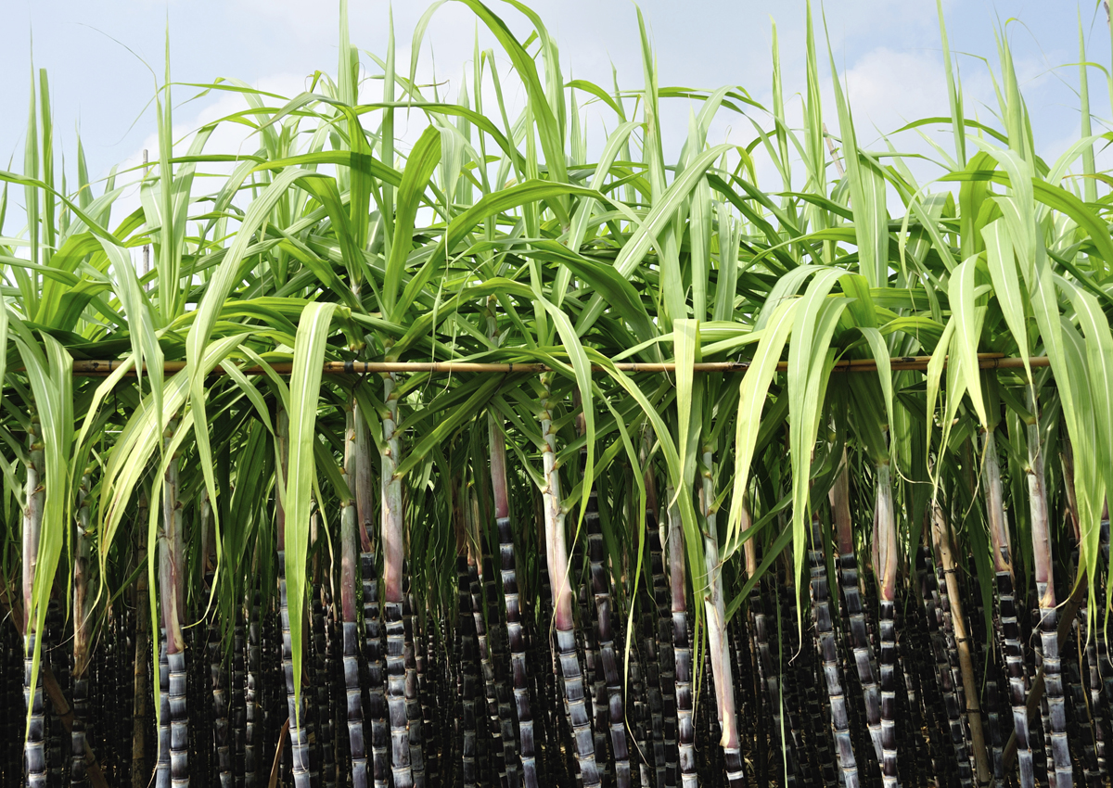

Submitted By: Shubhangi Kumar

Submitted to: Dr Sudhir Kumar

Department of Biotechnology and Bioinformatics, JUIT Waknaghat, Solan,

Minor Project 6th semester

INTRODUCTION:

With rapid industrial and agricultural development, large quantities of industrial and agricultural waste have been generated. Disposal of these wastes is a serious environmental problem, as most final wastes go to landfills, which not only reduces useful land area but also pollutes the environment. Industrial by products, such as coal fly ash, silica fume, and blast furnace slag, have been successfully used in cementitious materials and have achieved sufficient social and environmental benefits.

Currently, agricultural and forestry residues are mainly used as biomass fuel. The resulting bottom ash or fume ash is the final waste, which has aroused wide research interest. It has been found that many different kinds of biomass ash can be used as supplementary cementitious materials, such as rice husk ash, palm oil fuel ash, elephant grass ash, sugar cane bagasse ash, corn cob ash, wood waste ash, bamboo stem ash, cattle manure ash, and paper mill ash. Previous studies found that incorporating biomass ash into cementitious materials could maintain or even improve the mechanical performance of the cementitious materials.

Additionally, the incorporation of biomass ash into cementitious materials can help to reduce the greenhouse gases produced in cement production, lower the costs of construction materials, alleviate waste disposal pressure, and prevent soil and air pollution.

Sugar cane is a kind of tropical and subtropical crop and is the main sugar crop worldwide. Global sugar crop acreage is approximately 31.3 million hectares, among which sugar cane accounts for approximately 70%. The world's top three sugar-producing countries are Brazil, India, and China, which accounted for 20.57%, 16.91%, and 6.31% of the global production in 2016, respectively. Recently, sugar cane acreage reached approximately 1.23 million hectares in China, and production was approximately 100 million tons in 2017/2018. Sugar cane is typically used to produce sugar and ethanol.

OBJECTIVE:

In this study the main objective was to re-use sugarcane bagasse in an efficient and cost-effective manner. India produces about 9 million tons of sugarcane bagasse annually which is a large quantity to dispose, this can be a critical concern for sugar industry due to lack of disposal land and environmental restrictions. Therefore, it is very obligatory for us to re-use sugarcane bagasse.

Way to use Sugarcane Bagasse:

1. **Utilization of sugarcane bagasse ash in concrete as partial replacement of cement**-

Sugarcane bagasse is an environmental nuisance, according to Barroso that one ton sugarcane generates the 280 kg of bagasse waste which creates economic as well as environmental related issues. To reduce the environmental burden, the usage of waste materials in concrete is a significant aspect, the sugarcane bagasse ash (SCBA) is a waste material of sugar industry, which has a good potential to utilize in concrete as cement replacement.

1. **Biofuels and bio-based chemicals from sugarcane bagasse-**

Bagasse mainly constitutes of 45–50% water, 40–45% fibbers, and dissolved sugars of 2–5%. The fibrous component is mostly composed of 40–50% cellulose, 25–35% hemicellulose and 20–30% lignin therefore can be used variety of biofuels, biochemicals, and surplus electricity generation.

* Biofuels:

1. Biobutanol: has certain attractive features as a liquid fuel in comparison to ethanol. However, butanol yield through the Acetone-Butanol-Ethanol (ABE) fermentation method is low. Improvements in pre-treatment methods and microbial strains (mainly clostridium), as well as optimization of fermentation parameters have been explored to increase the yields biobutanol. Yields of bagasse derived butanol vary from 0.08 to 0.29 g/g depending upon the pre-treatment, microbial strain, cellulose or hemicellulose fraction used.
2. Biohydrogen: Biohydrogen (H2) is a clean-burning fuel with a calorific value of 122 kJ/kg, 2.75 times superior to that of other hydrocarbon fuels. Moreover, the combustion of H2 generates environmentally benign water. Thus, H2 can be a promising alternative for power generation, transportation, and industrial applications.
3. Biogas: Biogas has varied applications as a promising alternative for natural gas in domestic as well as industrial applications, as precursor to produce biobased chemicals, and for production of electricity, heat, and co-generation. Organic wastes are subjected to anaerobic digestion that involves hydrolysis of substrate followed by fermentation of substrate and further steps of acetogenesis followed by methanogenesis to yield biogas. Studies show that bagasse for biogas production have looked at different pre-treatment routes and recovery processes that increase biogas yields to values reported in the range of 122.3–480 mL/g volatile solids.

* Bio-based Chemicals:

1. Sugar alcohols: Xylitol, a low-calorie substitute for sucrose with 40% lesser calories, has varied applications in food, pharmaceutical, and industries. At a global production of 161.5 Million Metric Tons (MMT) annually, xylitol possesses a market value of US $670 million as of 2013. 2009). Xylitol yields ranging up to 0.55 g/g from hemicellulose fraction of bagasse have been achieved.
2. Organic acids: Bagasse can produce organic acids such as lactic acid, its yield ranges between 0.71 and 0.94 g/g, citric acid with yield of 0.087 to 0.097 g/g, succinic acid with yield of 0.80 g/g, butyric acid with yield of 0.48 g/g and gluconic acid with yield of 0.96 g/g. These acids derived from bagasse as substrate can be cost-effective compared to first generation feedstocks and environmentally less polluting than fossil derived counterparts.

METHODOLOGY:

1. In this experiment I went through different research papers from different scientist and universities.
2. I read different research paper on how sugarcane bagasse ash is being used and can be used.
3. How sugarcane bagasse is being used in different countries like Brazil, Malasia etc.
4. Then I picked papers that could be practically be possible in a large scale in India, which are even cost effective and don’t require a lot of man power.

RESULT:

• SCBA in concrete gives the higher compressive strength as compared to the normal strength concrete, hence optimal results were found at the 5% replacement of cement with SCBA.

• The usage of SCBA in concrete is not only a waste-minimizing technique, also it saves the amount of cement.

• Biofuels and bio-based chemicals can be very useful for the industries and is a very cost effective biproduct.

CONCLUSION:

SCBA is conventionally used as fertilizer or is disposed of in landfills, both of which are not sustainable from the standpoint of environmental and health concerns. Utilization of SCBA in construction materials offers a promising solution for superior recycling and management of SCBA wastes. By consolidating the findings from research, the following conclusions are obtained:

1. The successful utilization of SCBA in cementitious material, improved the short-term mechanical properties and long-term durability of mortar, concrete, and other construction materials. The durability of concrete containing SCBA exposed to severe environments lacks in-depth analyses. The influence of SCBA on reinforced concrete (RC) has rarely been reported.
2. The heterogeneity of SCBA constrains the large-scale application of SCBA in cementitious materials. Calcination is one of the most important influencing factors on SCBA composition. More attention should be focused on the congenator design, calculation control, bagasse drying process, etc., to obtain desirable SCBA pozzolanic activity.
3. There are both advantages and limitations of different processing methods that affect the SCBA pozzolanic activity.
4. Recently, ultrahigh performance concrete (UHPC) has become a research hotspot in civil engineering materials. Rice husk ash has been successfully used in UHPC as both a pozzolanic admixture and an internal curing agent. However, the potential utilization of SCBA in UHPC remains a virgin field well worth being explored.
5. For the large-scale application of SCBA, further research is needed on technical and environmental aspects, and standardization and governmental policy guidance.

I believe that use of SCBA can be done in many ways mentioned above but using it as a substitute of cement will widely benefit humans and our environment overall. The amount of population released from the cement factories would be controlled and the cement material produced from SCBA will be cheap to manufacture resulting in availability to public at low rates. Which will help the poverty population of our country to build their houses as well.

REFRENCES:

1. Barroso J, Barreras F, Amaveda H and Lozano A, 2003 On the optimization of boiler efficiency using bagasse as fuel, DOI:10.1016/S0016-2361(03)00061-9
2. Mangi, S. A., Jamaluddin, N., Wan Ibrahim, M. H., Abdullah, A. H., Abdul Awal, A. S. M., Sohu, S., & Ali, N. (2017). Utilization of sugarcane bagasse ash in concrete as partial replacement of cement. IOP Conference Series: Materials Science and Engineering, 271, 012001.
3. Barroso, J., Barreras, F., Amaveda, H., & Lozano, A. (2003). On the optimization of boiler efficiency using bagasse as fuel. Fuel, 82(12), 1451–1463.